Lesson 4 Demo 4: Rollout Pause and Resume

This section will guide you to:

* Pause and resume the rollout status

This lab has one sub-section, namely:

1. Pause and resume the rollout status

**Note:** If you don’t have an existing Kubernetes cluster, refer to the Demo 1.1 of Lesson 1.

**Step 1:** Pause and resume the rollout status

* Start the kubernetes cluster in the lab
* You can pause a deployment before triggering one or more updates and then resume it. This allows you to apply multiple fixes in between pausing and resuming without triggering unnecessary rollouts  
  **For example**: With a Deployment that was just created, get the deployment details as shown below:

*kubectl get deployments*

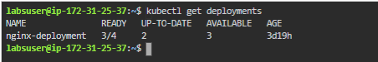

* Next, get the rollout status as shown below:

*kubectl get rs*

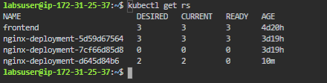

* Let’s now pause the deployment by running the command as shown below:  
    
  *kubectl rollout pause deployment.v1.apps/nginx-deployment*



* Next, let’s update the image of the deployment as shown below:  
    
  *kubectl set image deployment.v1.apps/nginx-deployment nginx=nginx:1.9.1*



* Notice that no new rollout has started, so we can check the rollout history  
    
  *kubectl rollout history deployment.v1.apps/nginx-deployment*

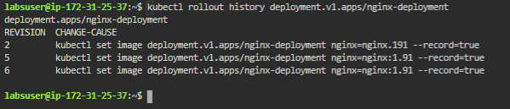

* Eventually, resume the deployment and observe a new ReplicaSet coming up with all the new updates as shown below:  
    
  *kubectl rollout resume deployment.v1.apps/nginx-deployment*

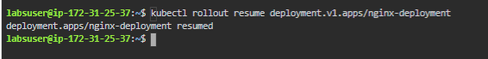

* Get the status of the latest rollout, as shown below:  
    
  *kubectl get rs*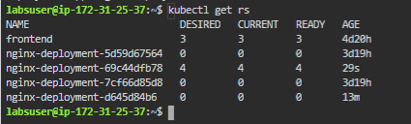
* You can see that all the deployments are running with updated changes